|  |
| --- |
| C:\Users\Ranthako\Documents\FINANCE\Sebata\Programs\Mantsopa logo - small2.bmp  **FINANCE DEPARTMENT** |
| **QUARTERLY SECTION 52(d) REPORT AND TREASURY REPORTS QUARTER-ENDED: 31 MARCH 2019** |
|  |

|  |
| --- |
|  |

Prepared by: TS Mphezulu

Budget Accountant ___________________

1st Reviewer: P Le Roux

Budget Manager ___________________

2nd Reviewer: SA Nyapholi

Chief Financial Officer ___________________

Approved by: TP Masejane

Municipal Manager ___________________

**Table of Contents**

**Chapter 1: LEGISLATIVE FRAMEWORK**

* 1. Purpose
  2. Strategic objective
  3. Background

**Chapter 2: BUDGET PERFORMANCE ANALYSIS**

2.1 Revenue Vs Expenditure Comparison (Annexure A)

2.1.1 Operating Income (Annexure A)

2.1.2 Operating Expenditure (Annexure A)

2.2 Capital expenditure (Annexure B)

2.2.1 Municipal Infrastructure Grant

2.2.2 Rural Bulk Infrastructure grant

2.2.3 Water Services Infrastructure Grant

2.2.4 Financial Management Grant

2.3 Debtors Analysis (Annexure C)

2.4 Creditors Analysis (Annexure D)

**Chapter 3: COLLECTION RATE**

3.1 Billing and Payments Ratio Report

3.2 Revenue Management

**Chapter 4: EXPENDITURE MANAGEMENT**

4.1 Personnel Cost to Total Expenditure

4.2 Repairs and Maintenance to Total Expenditure

**Chapter 5: CURRENT ASSETS MANAGEMENT**

5.1 Debtors Collection Period

**Chapter 6: CORRECTIVE MEASURES**

6.1 Appointment of credit control personnel

6.2 Data Cleansing

**Chapter 7: Annexures**

7.1 Annexure A: Statement of Financial Performance

7.2 Annexure B: Statement of Capital Expenditure

7.3 Annexure C: Age Debtors

7.4 Annexure D: Age Creditors

**CHAPTER 1: LEGISLATIVE FRAMEWORK**

**THE MUNICIPAL MANAGER**

**THE MAYOR**

**MUNICIPAL FINANCE MANAGEMENT ACT (MFMA) BUDGET AND PERFORMANCE ASSESSMENT REPORT IN TERMS OF THE MFMA, SECTION 52 (d), FOR THE QUARTER ENDED 31 March 2019**

* 1. **PURPOSE**

The purpose of this report is to inform Council of the 3rd Quarter performance. (up to 31 March 2019) against the approved budget in compliance with Section 52 (d) of the MFMA and the requirements as promulgated in the Government Gazette No 32141 of 17 April 2009, by providing a statement on the implementation of the budget and financial state of affairs of the municipality to the Mayor, as legislated.

* 1. **STRATEGIC OBJECTIVE**

The strategic objective of this report is to ensure good governance, financial viability and optimal institutional transformation with capacity to execute its mandate.

* 1. **BACKGROUND**

Section 52(d) of the MFMA and Section 28 of Government Gazette Notice 32141 dated 17 April 2009, regarding the Local Government: Municipal Finance Management Act of 2003 and Municipal Budget and Reporting Regulations” necessitates that specific financial particulars be reported on prescribed format, hence this report to meet legislative compliance.

In terms of section 52(d) of the MFMA, – “The mayor of a Municipality -

(d) Must, within 30 days of the end of each quarter, submit a report to the council on the implementation of the budget and the financial state of affairs.

*In terms of section 71(1) of the MFMA*

“The accounting officer of a municipality must by no later than 10 working days after the end of each month submit to the mayor of the municipality and the relevant provincial treasury a statement in the prescribed format on the state of the municipality’s budget reflecting the following particulars for that month and for the financial year up to the end of that month.

*The Municipal Budget and Reporting Regulations section 28 stipulates that:*

“The monthly budget statement of the municipality must be in a format specified in Schedule C and include all the required tables, charts and explanatory information, taking into account any guidelines Issued by the Minister in terms Section 168(1) of the MFMA.

Furthermore Section 31(1) prescribes the following:

“The mayor’s quarterly report on the implementation of the budget and financial state of affairs of the municipality as required by Section 52(d) of the Act must be –

1. In the format specified in Schedule C and include all the required tables charts and explanatory information, taking into account any guidelines issued by the Minister in terms Section 168(1) of the Act; and
2. Consistent with the monthly budget statement for January, February and March 2019 as applicable: and
3. Submitted to the National Treasury and relevant Provincial Treasury within five (5) days of tabling of the report in the council.

**CHAPTER 2: BUDGET PERFORMANCE ANALYSIS**

**REPORT FOR THE QUARTER ENDED 31 March 2019**

This report is based upon financial information, as at 31 March 2019 and available at the time of preparation. All variances are calculated against the approved **Adjustment** **budget** figures. The results **for the quarter ended 31 March 2019** are summarized as follows:

**2.1 Revenue Vs Expenditure Comparison Statement of Financial Performance (SFP)** (**Annexure A** **–Table C4**)

The SFP shown in Annexure A is prepared on a similar basis to the prescribed budget format, detailing revenue by source, excluding capital transfers and contributions, and expenditure by type.

The summary report indicates the following:

The actual performance for the three months period ending 31 March 2019 (excluding capital transfers and contributions) on the operating budget can be summarised as follows:

|  |  |  |  |  |
| --- | --- | --- | --- | --- |
|  | **Total Adjustment Budget**  **R’000** | **3rd Quarter Budget**  **R’000**  **A** | **3rd Quarter Actual**  **R’000**  **B** | **Variance**  **R’000**  **A-B** |
| Revenue by source | 244 537 | 61 134 | 55 316 | 5 818 |
| Expenditure by type | 239 248 | 59 812 | 50 197 | 9 615 |
| **Surplus/(Deficit)** | **5 289** | **1 322** | **5 119** | **(3 797)** |

**Note**:

* The total Actual Revenue includes total operational grant and excludes Capital grants received from National Treasury as per the payment schedule for the quarter.

**2.1.1 Operating Revenue**

The following is the collected revenue performance of the municipality for the 3rd Quarter of the financial year.

|  |  |  |  |  |  |  |  |
| --- | --- | --- | --- | --- | --- | --- | --- |
| **Adjustment Budget 2018/19 R’000** | **Actual**  **January**  **2019** | **Actual February 2019** | **Actual**  **March 2019** | **Actual Total Quarter 3**  **2019** | **Budgeted**  **Total Quarter 3 2019** | **Variance R’000** | **Variance %** |
| 244 537 | 8 798 | 6 636 | 53 154 | 55 316 | 61 134 | 5 818 | 9.5% |

The detailed cumulative year to date performance for the 3rd Quarter is outlined below:

**The major revenue sources against the original budget are:**

* **Property rates**: During the 3rd Quarter property rates were billed at R1 282m by the Municipality and the following months corrections will be made. This also include arrears, and yearly payment of property rates by farmers and R2 618m was collected.
* **Water Revenue**: The Municipality budgeted a total of R 8,961m on water, billed R11, 483 m and collected R3,625 m during the 3rd quarter.
* **Sanitation/ Sewerage Revenue:** The 3rd Quarter budgeted amount is R4,560m, billing for the sanitation was R4,703m and collected R1,642m.
* **Refuse Revenue:** The Municipality budgeted R3, 225m, billed R3, 299m and collected R1,061m.
* **Electricity Revenue**: During the 3rd Quarter the municipality budgeted R8,311m, In January the municipality billed R329 thousand and in February -R388 thousand was reversed due to the electricity business being with Centlec and in March R427 thousand was billed and the total billing for the quarter was R369 thousand and collected R12,109m this includes amounts received by the municipality and payment received from Centlec.
* All billings by Mantsopa for electricity will be reversed and only the payments received from Centlec will be shown as income.

Graphical illustration of the total budgeted income figures versus the actual figures for the 3rd quarter.

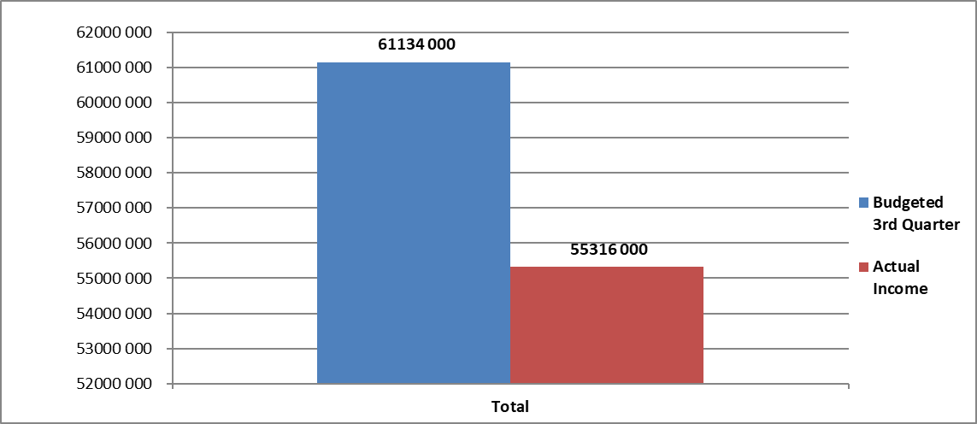

**2.1.2 Operating Expenditure**

The following is the expenditure performance of the municipality for the 3rd Quarter of the financial year.

|  |  |  |  |  |  |  |  |
| --- | --- | --- | --- | --- | --- | --- | --- |
| **Adjustment Budget 2018/19 R’000** | **Actual**  **January**  **2019** | **Actual February**  **2019** | **Actual March 2019** | **Actual Total Quarter 3**  **2019** | **Budgeted Total Quarter 3 2019** | **Variance R’000** | **Variance %** |
| 239 248 | 18 956 | 19 656 | 11 585 | 50 197 | 59 812 | 9 615 | 16% |

**The major operating expenditure variances against original budget are:**

* **Employee Related costs and Remuneration of Councilors:** The total employee related costs and remuneration of councilors is at R24 460m for the third quarter.
* **Bulk purchases:** The total purchases for the quarter was at R7 629m.
* **Other Expenditure, grants and subsidies paid, contracted services and Repairs Maintenance:** Water Chemicals and hiring of Equipment and the repairs and maintenance. The total cost on other expenditure for the third Quarter is R17 807m.

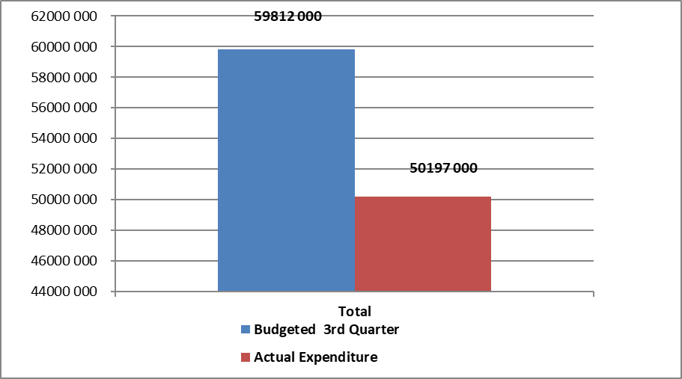

**2.2 Capital expenditure report** (**Annexure B** **Table C5)**

Details of the above are available on **Annexure B Table C5**

**2.2.1 Municipal Infrastructure Grant Expenditure**

|  |  |  |
| --- | --- | --- |
| **MIG Project Description** | **Adjustment Budget**  **‘000** | **Actual Expenditure**  **‘000** |
| 1. PMU | R 1 638 | R 1 585 |
| 1. Manyatseng Ext 9:383 Toilet top structures | R 1 851 | R 1 813 |
| 1. Upgrading Arthur Pitso Stadium | R 0 | - |
| 1. Manyatseng 1.7km Road & storm water | R 4 561 | R 2 717 |
| 1. High Mass lights | R10 291 | R8 617 |
| 1. Dipelaneng sports Stadium | R 12 459 | R 3 739 |
| 1. Boroa/ Tweespruit: Upgrading sports field | R1 440 | - |
| 1. Excelcior erection of 730m of concrete palisade | R481 | R 488 |
| 1. Dipelaneng: Construction of 2 km paved ring road | R38 | - |
| **Total** | **R 32 759** | **R 18 959** |

Details of the above are available on **Annexure B Table C5**

**2.2.2 Regional Bulk infrastructure grant (RBIG)**

|  |  |  |
| --- | --- | --- |
| **RBIG Project Description** | **Adjusment Budget**  **‘000** | **Actual Expenditure**  **‘000** |
| 1. Two Boreholes in Tweespruit | R14 376 | R12 806 |
| 1. Bulk Water Supply Excelsior | R2 777 | R4 992 |
| 1. Bulk Water Pipeline new hospital | R347 | R442 |
| **Total** | **R17 500** | **R18 240** |

**2.2.3 Water Services Infrastructure Grant (WSIG)**

|  |  |  |
| --- | --- | --- |
| **WSIG Project Description** | **Adjusment Budget**  **‘000** | **Actual Expenditure**  **‘000** |
| 1. Water Cons & Water Demand Management | R10 000 | R1 616 |
| **Total** | **R10 000** | **R 1 616** |

**2.2.4 Finance Municipal Grant (FMG)**

|  |  |  |
| --- | --- | --- |
| **FMG Project Description** | **Adjusment Budget**  **‘000** | **Actual Expenditure**  **‘000** |
| 1. Municipal Finance management Programme | R81 | R1 |
| 1. Salaries | R500 | R378 |
| 1. System Maintenance | R1134 | R986 |
| 1. Annual Financial Statements | R435 | R435 |
| **Total** | **R2215** | **R 1 984** |

**2.3 Debtors Analysis As at 31 March 2019**

The drastic increase in debtor in a huge concern as it results in cash flow problems.

Households are the biggest debtors for the municipality contributing 69% to the total debtor’s figure.



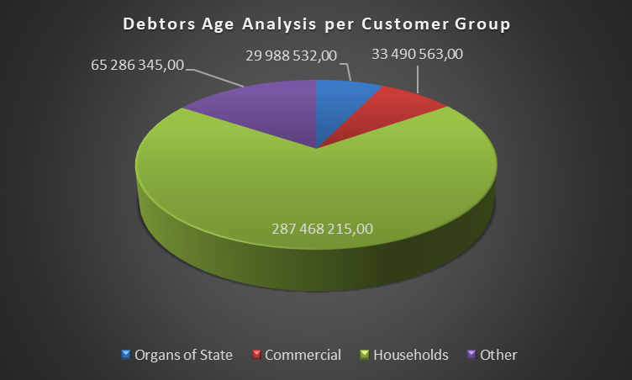

**2.4 Creditors Analysis As at 31 March 2019 (Table SC4 Age Creditors Annexure D)**



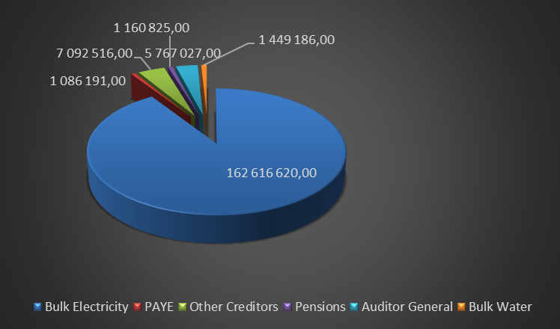

Outstanding creditors for the period under review amount to approximately R 179 172m on the 31st March 2019.

* Bulk electricity is 90 % of the total debt at R162 616m and Bulk water at R1 4m.
* Other Creditors is at 4% of the total debt and amounts to R7 092m.
* PAYE accounts to 1% of the total debt and amounts to R1 1m.
* Auditor General accounts for 3% and pensions at 1% of the total debt.

The municipality’s policy is to pay its creditors within 30 days of date of the creditors invoices. This is not always possible as the municipality is under financial distress.

**Chapter 3: COLLECTION RATE**

**3.1 Billing and payments ratio report**

|  |  |  |  |  |
| --- | --- | --- | --- | --- |
| **Description** | **Actual**  **January 2019**  **R’000** | **Actual**  **February**  **2019**  **R’000** | **Actual**  **March**  **2019**  **R’000** | **Total for the Quarter 3** |
| Billings | 8 644 | 9 617 | 10 270 | 28 563 |
| Receipts | 1 943 | 2 165 | 2 613 | 6 702 |
| **Payment %** | **22%** | **22%** | **25%** | **23%** |

*This excludes Rental of facilities and equipment, Interest earned on external investment, operational transfers and other income.

The payments from Centlec have been excluded in the calculation.

**3.2 Revenue Management**

* **Level of Reliance on Government Grants**

**Purpose**: The purpose of this ratio is to determine what percentage of the municipality’s revenue is made up of government grants to determine the level of reliance on government funding by the municipality for its operations.

**Formula**: Grants & Subsidies/Total Revenue

These figures are found in the financial system of the Municipality

|  |  |  |
| --- | --- | --- |
| **Description** | **Total Ajustment Budget** | **Actual Quarter** |
| **Operational Grants** | **R’000** | **R’000** |
| Equitable Share | 74 811 | 18 703 |
| Financial Management Grant | 2 215 | 0 |
| Expanded Public Works Program | 1 130 | 0 |
| MIG Operational | 1 638 |  |
| **Total Operational Grants** | **80 721** | **18 703** |
|  |  |  |
| **Total Operational Income** | **244 537** | **61 134** |
| **Percentage over Total Income anticipated** | **33%** | **31%** |
|  |  |  |

**Chapter 4: Expenditure Management**

* 1. **Personnel Cost to Total Expenditure**

Purpose: The purpose of this ratio is to Indicate Personnel Cost as a percentage of Total Expenditure.

Formula: Salaries, Wages and allowances/Total Expenditure

The figures are found in the financial system of the municipality.

|  |  |  |  |
| --- | --- | --- | --- |
| **Description** | **Total Adjustment Budget**  **R’000** | **Actual Quarter 3**  **R’000** | **Budget Quarter 3**  **R’000** |
| Total Employee/ Councillors Related Cost | 97 931 | 24 760 | 24 483 |
| Total Operating Expenditure | 239 248 | 50 197 | 59 812 |
| **% of Personnel cost/Total Operating Exp** | **40.93%** | **49.32%** | **40.93%** |

* 1. **Repairs and Maintenance to Operating Expenditure**

**Purpose**: The purpose of this ratio is to determine whether municipalities are spending adequate amounts on Repairs and Maintenance of PPE.

**Formula**: Repairs and Maintenance/Total Operating Expenditure

These figures are found in the financial system of the municipality.

|  |  |  |  |
| --- | --- | --- | --- |
| **Description** | **Total Adjustment Budget**  **R’000** | **Actual Quarter 3**  **R’000** | **Budget Quarter 3**  **R’000** |
| Total Repairs and Maintenance | 13 672 | 468 | 3 418 |
| Total Operating Expenditure | 239 248 | 50 197 | 59 812 |
| % of R & M / Total Operating Expenditure | **5.7%** | **1%** | **5.7%** |

* Fraction of total repairs and maintenance budgeted on total operating expenditure budgeted is 5.7%.
* Repairs for the 3rd Quarter is 1% of the total expenditure.

**Chapter 5: CURRENT ASSETS MANAGEMENT**

* 1. **Debtors Collection Period**

Purpose: The purpose of this ratio is to calculate the debtor’s collection period of the municipality by comparing the end of quarter balance of certain debtors with the revenue earned from those debtors during the financial year.

Formula: Consumer Debtors before provision for Bad Debts/Total Revenue *365

The figures are found in the financial system of the municipality and provide a detailed explanation on the current status and challenges faced in debt collection

|  |  |
| --- | --- |
| **Description** | **Actual Quarter 3**  **R’000** |
| Consumer debtors before provision for bad debts | 36 099 |
| Total Operating Revenue | 59 797 |
| **Collection Period (Days)** | **220 days** |
| **Norm** | **30 days** |
| **Difference** | **190days** |

* The norm is 30 days and will be used as basis of interpretation.
* The municipality’s ratio for March is 190 days.
* The municipality is not within the norm and there should be a drastic improvement in the debt collection to be well in the Norm of 30 days.

**Chapter 6: CORRECTIVE MEASURES**

* 1. **Establishment of Credit control Unit**

The municipality has appointed an employee in the Credit Control Unit based on the current organogram, the unit which will assist with collections between 0 and 90 days.

**6.2 Data cleansing**

The Fezi Auditors and consultants have performed the data cleansing exercise and the reconciliation between the valuation roll and the system is in process of being finalized.

**6.3 REVCO**

Revco has been appointed to collect on behalf of the municipality on accounts that are in arrears for more than 90 days.

**QUALITY CERTIFICATE**

**I …………………………………………………………………..** The Municipal Manager of Mantsopa Local Municipality Hereby certify that:

The Quarterly Budget Monitoring Reports (Section 52d of the Municipal Finance Management Act 56 of 2003)

For the quarter ended 31 March 2019 has been prepared in accordance with the Municipal Finance Management Act and Regulations made by the Act

Municipal Manager of Mantsopa Local Municipality (FS196)

………………………………………

Signature

………………………………………..

Date